**A Report On NYC Short-Term Rental Insights Report**

Submitted by: Agbataekwe Chuks Chukwunonso

Submitted to: Masterschool

Date: 19-06-2023

KPI dashboard link:https://public.tableau.com/app/profile/chuks.chukwunonso.agbataekwe/viz/Mystryproject2/Dashboard2?publish=yes

The loom presentation video: <https://www.loom.com/share/4e6ea0b6e66c47a8ba53548f489cb24c?sid=d2bfd390-bf91-4d95-b5f9-20eb74b40d5a>

**CHAPTER 1**

**Introduction:**

**NYC Short-Term Rental Insights Report**

This project analysis is to analyze the New York City short-term rental insights, some data was given with three different tables which are Prices, Reviews and room types. This analysis will help Pillow Palooza to know the most profitable areas and properties to invest in.

The project will be divided into three parts:

* Data Wrangling and Cleaning
* Data Analysis and Insights Generation
* Presenting your findings for Business Impact

**Data Wrangling and Cleaning**

* The data which was a raw data was cleaned with the help of the google spreadsheet these steps were taken:
* Data Collection, Data Inspection, Data Cleaning, Data Transformation, Data Integration, Data Formatting, Data Validation and Documentation

**Data Analysis and Insights Generation**

The tool that was used here was the Structured Query Language (SQL), where the three tables which are the prices, reviews and room types table were being analysed based on the question of the sprints.

**Presenting your findings for Business Impact**

In this stage, tableau public was used to analys and present my business questions. These questions were based on some questions which are:

* Most popular Neighborhood for short-term rental in New York City.
* Most commonly rented property types of Airbnb in New York City.
* Top 5 average rental prices in New York City Neighborhood.

**CHAPTER 2**

**RESULTS**

**2.1.Tableau Results:**

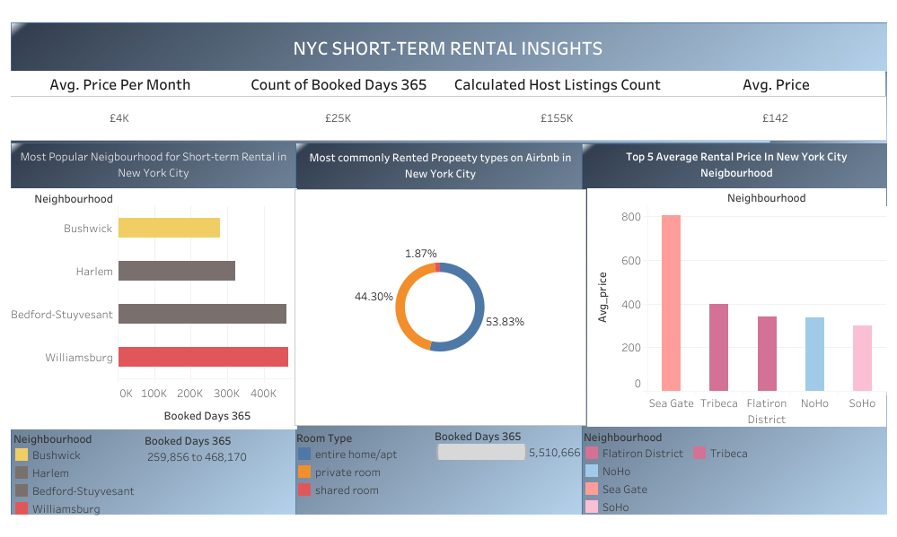

KPI Dashborad

The dashboard link: <https://public.tableau.com/app/profile/chuks.chukwunonso.agbataekwe/viz/Mystryproject2/Dashboard2?publish=yes>

The loom presentation video: <https://www.loom.com/share/4e6ea0b6e66c47a8ba53548f489cb24c?sid=d2bfd390-bf91-4d95-b5f9-20eb74b40d5a>

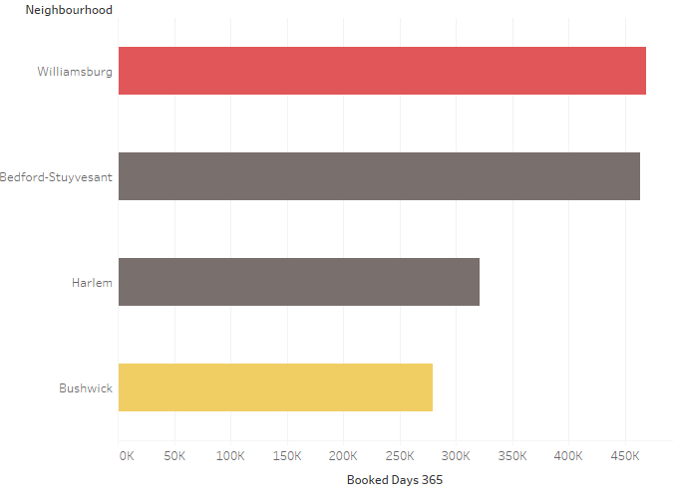

Most popular Neighborhood for short-term rental in New York City.

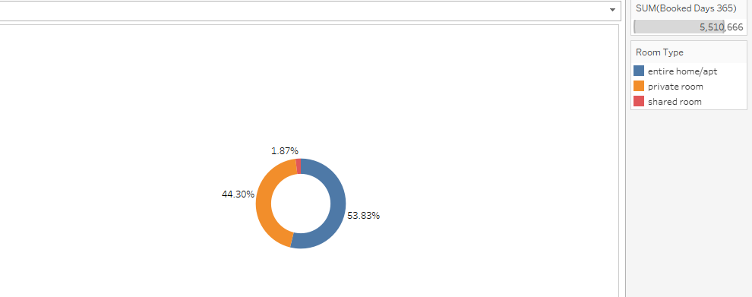

Most commonly rented property types of Airbnb in New York City.

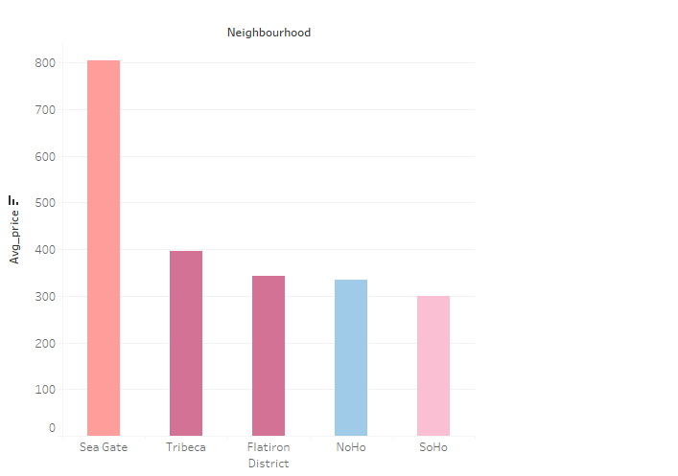

Top 5 average rental prices in New York City Neighborhood

**2.2. SQL QUERY RESULTS**

-- Example query (PostgreSQL)

SELECT * FROM "prices";

-- Tips:

-- (*) Table names containing punctuation, capitalization, or spaces should be

--     quoted, e.g. "Test Data.csv".

-- (*) Add more data by using the Upload Data button.

-- (*) Create additional schemas for namespacing your tables, e.g. "CREATE SCHEMA my_schema;".

-- (*) When querying tables created outside of the public (default) schema,

--     be sure to specify the desired schema, e.g. "SELECT * FROM my_schema."my data.csv";".;

--1. What is the most common room type in NYC Airbnb listings?

SELECT room_type,  COUNT (*) AS count

FROM room_types

GROUP BY room_type

ORDER BY count DESC

LIMIT 1;

--2. What is the average price of a listing by room type?

SELECT AVG(p.price) AS avg_room_type

FROM prices p

JOIN room_types r ON p.listing_id = r.listing_id

WHERE room_type = 'shared room'

--3. Which borough has the highest average price per month?

SELECT borough, AVG(price) AS average_price

FROM prices

GROUP BY borough

ORDER BY average_price DESC

LIMIT 1;

--4. How many listings of each room type are in each borough?

Complete the ___???___ with the correct answer.

SELECT p.borough, r.room_type, COUNT(*) AS count_listing

FROM prices p

JOIN room_types r ON p.listing_id = r.listing_id

GROUP BY p.borough, r.room_type;

--6.. What is the distribution of listing prices by borough?

Complete the ___??___ with the correct answer

SELECT borough, COUNT(*) AS count_listings, AVG(price) AS average_price, MIN(price) AS min_price, MAX(price) AS max_price

FROM prices

GROUP BY borough;

--7.. What is the estimated amount of revenue generated by hosts in each borough?

Complete the ___???___ with the correct answer.

SELECT p.borough , SUM (price * booked_days_365) AS revenue

FROM prices p

JOIN reviews r ON p.listing_id = r.listing_id

GROUP BY p.borough;

--8.. What is the average price per month for listings in each neighborhood?

Complete the ___???___ with the correct answer.

SELECT p.neighbourhood ,r.room_type, AVG(p.price_per_month) as avg_price_per_month

FROM prices p

JOIN  room_types r on p.listing_id = r.listing_id

WHERE neighbourhood = 'Sea Gate'

GROUP BY p.neighbourhood ,r.room_type;

--9.. How many listings have no reviews?

SELECT COUNT(listing_id),  number_of_reviews

FROM reviews

WHERE number_of_reviews < 1

GROUP BY listing_id,  number_of_reviews;

**CHAPTER 3**

**RECOMMENDATION AND CONCLUSION**

In recommendation to Pillow Palooza, this points should be put into consideration

* Williamsburg should be considered as a better neighbourhood to start-up an Airbnb short-term rental, this is because it has the highest amount of booking per year in New York City. It should also be rented on an average price of £142 to be affordable for customers.
* Entire home/apartment and private rooms should be the properties to be invested in, this is because people in the New York neighbourhood prefer to rent such properties than the share room apartment.

In conclusion, from the SQL analysis and tableau presentation, it shows how important and profitable the New York Airbnb investment is, and Williamsburg is a suitable neighbourhood for pillow palooza to invest in, this is with the aid of properties such as entire home/apartment and private rooms.